# Junit Basic Testing Exercises

**Exercise 1: Setting Up Junit**

**Code:**

**pom.xml(Junit):**

<?xml version="1.0" encoding="UTF-8"?>  
<project xmlns="http://maven.apache.org/POM/4.0.0"  
 xmlns:xsi="http://www.w3.org/2001/XMLSchema-instance"  
 xsi:schemaLocation="http://maven.apache.org/POM/4.0.0 http://maven.apache.org/xsd/maven-4.0.0.xsd">  
 <modelVersion>4.0.0</modelVersion>  
  
 <groupId>org.example</groupId>  
 <artifactId>JUnit</artifactId>  
 <version>1.0-SNAPSHOT</version>  
  
 <properties>  
 <maven.compiler.source>17</maven.compiler.source>  
 <maven.compiler.target>17</maven.compiler.target>  
 <project.build.sourceEncoding>UTF-8</project.build.sourceEncoding>  
 </properties>  
  
 <dependencies>  
 <dependency>  
 <groupId>junit</groupId>  
 <artifactId>junit</artifactId>  
 <version>RELEASE</version>  
 <scope>test</scope>  
 </dependency>  
  
 </dependencies>  
  
</project>

**Calculator.java:**

package org.example;  
  
public class Calculator {  
 public int add(int a, int b) {  
 return a + b;  
 }  
}

**CalculatorTest.java:**

package org.example;  
  
import static org.junit.jupiter.api.Assertions.*;  
  
class CalculatorTest {  
  
 @org.junit.jupiter.api.Test  
 void add() {  
 Calculator calc = new Calculator();  
 int result = calc.add(2, 3);  
 *assertEquals*(5, result);  
 }  
}

**Output:**

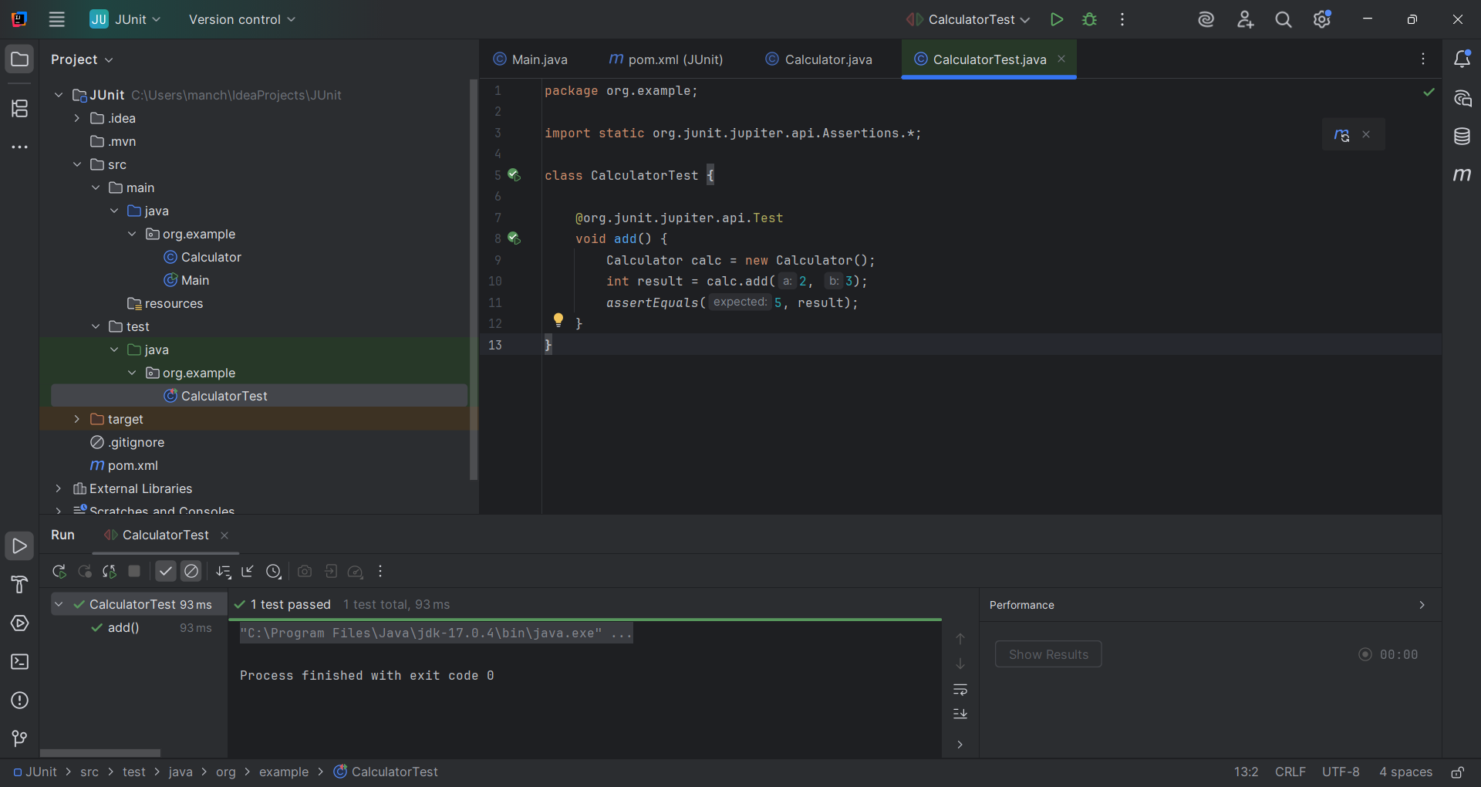

**Exercise 3: Assertions in Junit**

**AssertionsTest.java:**

import org.junit.jupiter.api.Test;

import static org.junit.jupiter.api.Assertions.*;

public class AssertionsTest {

@Test

public void testAssertions() {

assertEquals(5, 2 + 3, "2 + 3 should equal 5");

assertTrue(5 > 3, "5 is greater than 3");

assertFalse(5 < 3, "5 is not less than 3");

assertNull(null, "Value should be null");

assertNotNull(new Object(), "Object should not be null");

}

}

**OUTPUT:**

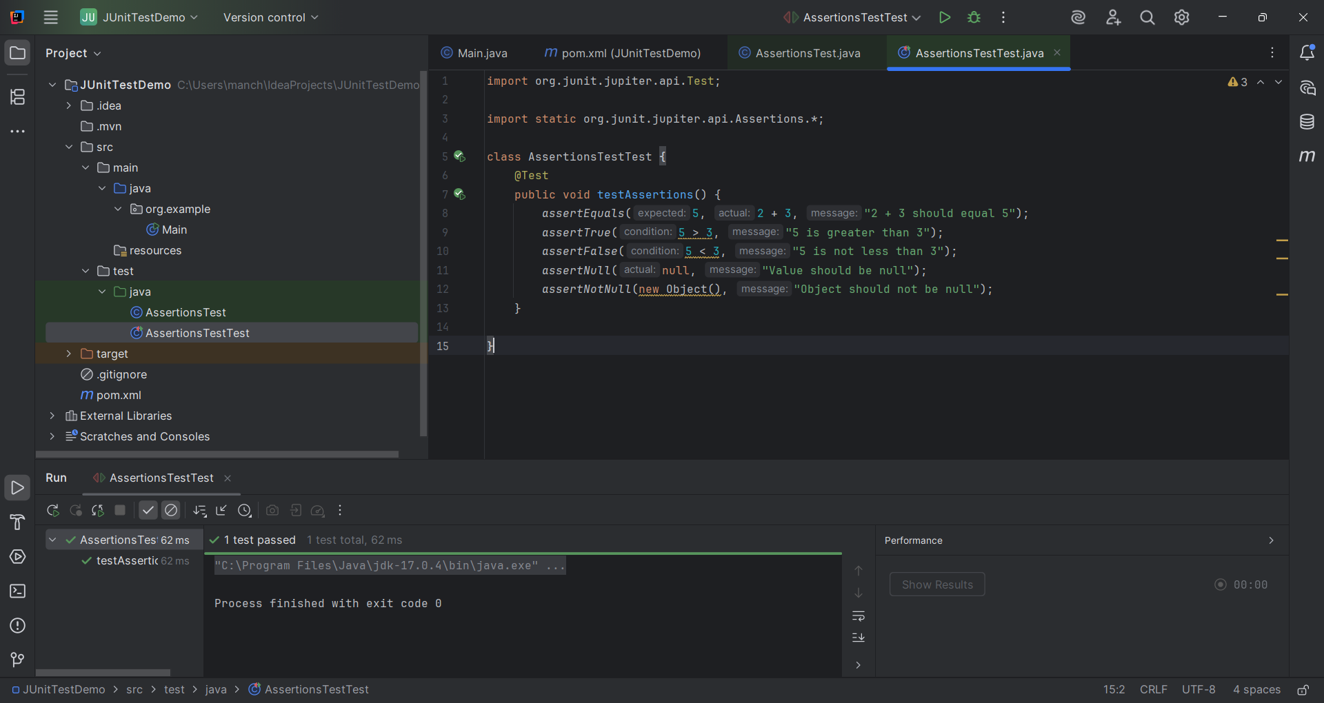

**Exercise 4: Arrange-Act-Assert (AAA) Pattern, Test Fixtures, Setup and Teardown Methods in Junit**

**Calculator.java:**

package org.example;  
  
public class Calculator {  
 public int add(int a, int b) {  
 return a + b;  
 }  
  
 public int subtract(int a, int b) {  
 return a - b;  
 }  
}

**CalculatorTesting.java:**

import org.example.Calculator;  
import org.junit.jupiter.api.BeforeEach;  
import org.junit.jupiter.api.AfterEach;  
import org.junit.jupiter.api.Test;  
import static org.junit.jupiter.api.Assertions.*;  
  
public class CalculatorTesting {  
  
 private Calculator calculator;  
  
 @BeforeEach  
 public void setUp() {  
 calculator = new Calculator();  
 }  
  
 @AfterEach  
 public void tearDown() {  
 calculator = null;  
 }  
  
 @Test  
 public void testAddition() {  
 int a = 5;  
 int b = 3;  
 int result = calculator.add(a, b);  
 *assertEquals*(8, result);  
 }  
  
 @Test  
 public void testSubtraction() {  
 int a = 10;  
 int b = 4;  
 int result = calculator.subtract(a, b);  
 *assertEquals*(6, result);  
 }  
}

**OUTPUT:**

